

**INTRODUCTION TO AZURE ML**

**In this session**

* What Bill have to say?
* What is Machine Learning?
* What is Azure ML?
* What is Azure ML Studio?
* Artificial Intelligence VS AI
* ML paradigm
* Everyday examples of predictive analytics
* Machine Learning work flow
* Machine learning language
* Cortana Intelligence Suite (CIS)
* Google Machine Learning
* Amazon Machine Learning

What Bill have to say?

“A breakthrough in machine learning would be worth ten Microsofts,”



Bill Gates

What is Machine Learning?

**What is Machine Learning?**

* 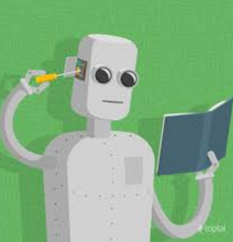Subfield of computer science
* Ability to learn without being explicitly programmed
* Algorithms that can learn from and make predictions on data
* Closely related to computational statistics
* Focuses on prediction-making
* Sometimes mixed with Data Mining (DM)
* Used complex models and algorithms
* Predictive analytics

Generations of data exploitation

3rd Gen

2nd Gen

1st Gen

Data

Report

Business Intelligence

Data

Data Base

Management System

Data mining

Programming

Data

Machine Learning

Insight

Prediction

Information

What is Azure ML?

**What is Azure ML?**

* 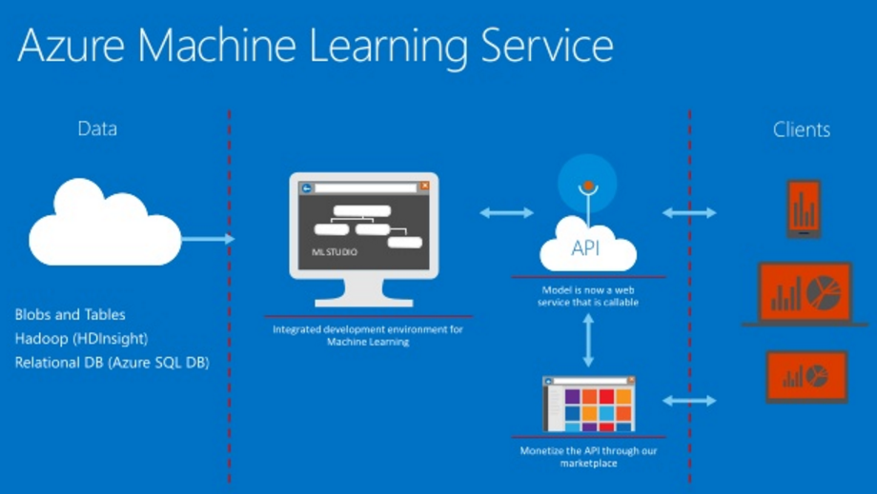Pronounce = Air-Cher
* Part of Azure Could platform
* Part of Cortana Intelligence Suite
* Platform as a service (PaaS)
* Create systems that improve with experience
* Help turning data into software
* Help training with huge volumes of data
* Used to predict certain patterns, trends, and outcomes
* Predictive analytics is the underlying technology
* Use the past to predict the future

What is Azure ML Studio?



**What is Azure ML Studio?**

* Is a collaborative tool
* Drag-and-drop
* Use to build, test, and deploy predictive analytics solutions
* Publishes models as web services
* Easily be consumed by custom apps or BI tools
* Is where data science, predictive analytics, cloud resources, and your data meet.

Artificial Intelligence VS ML

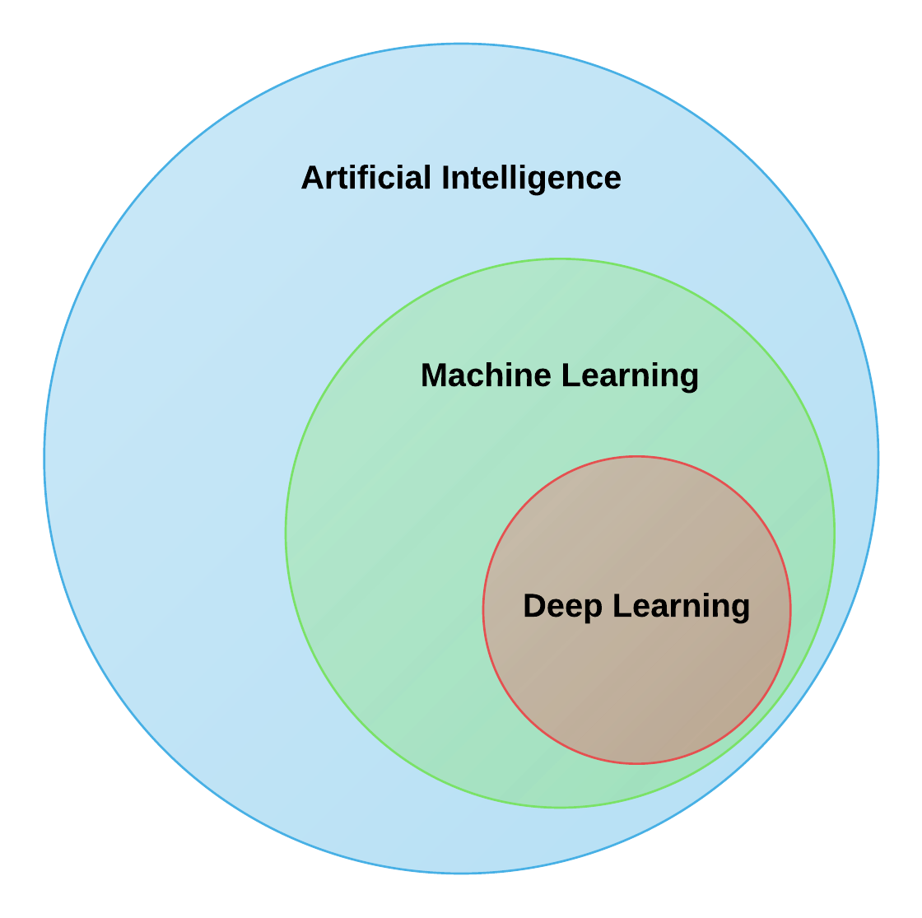

ML paradigm

Traditional Programming

Computer

Data

Output

Program

Machine Learning

Computer

Data

Output

Program

Everyday examples of predictive analytics

Everyday examples of predictive analytics

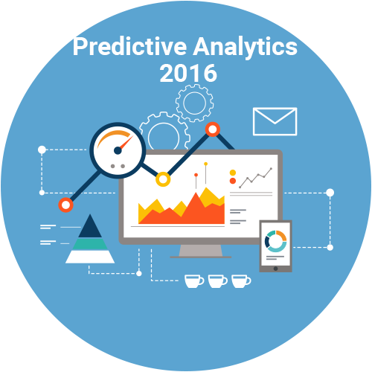

* Spam/junk email filters
* Mortgage applications
* Pattern recognition
* Life insurance
* Medical insurance
* Liability/property insurance
* Credit card fraud detection
* Airline flights
* Web search
* Predictive maintenance
* Health care

Machine Learning work flow

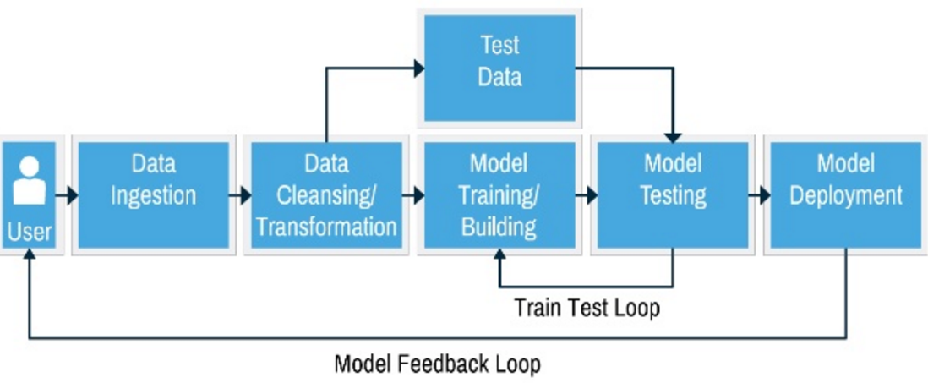

Machine learning language

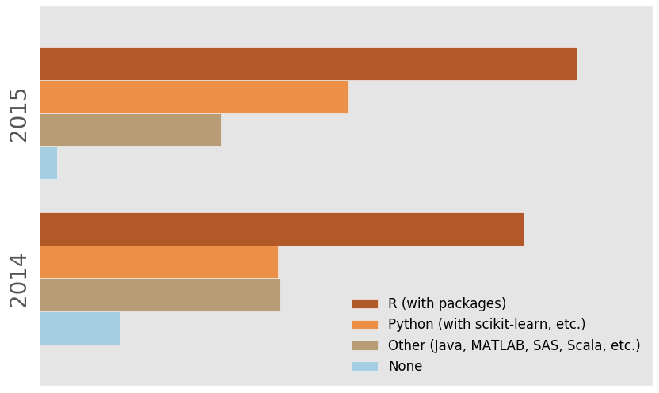

Cortana Intelligence Suite (CIS)

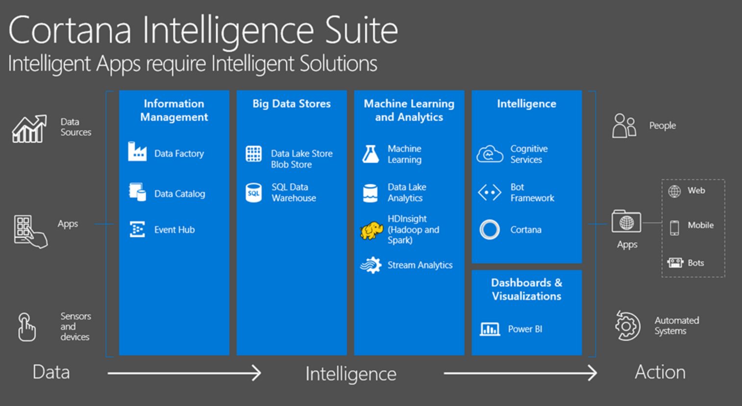

Google Machine Learning

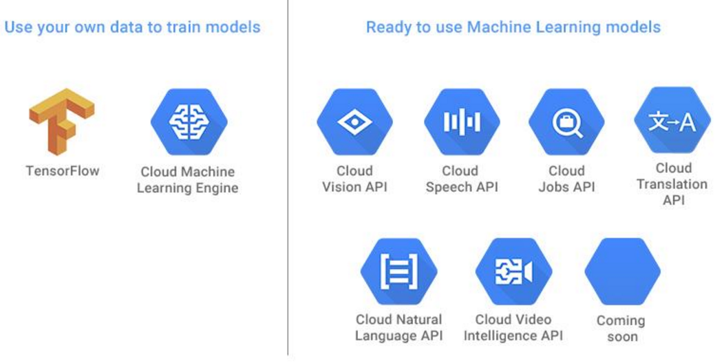

Amazon Machine Learning

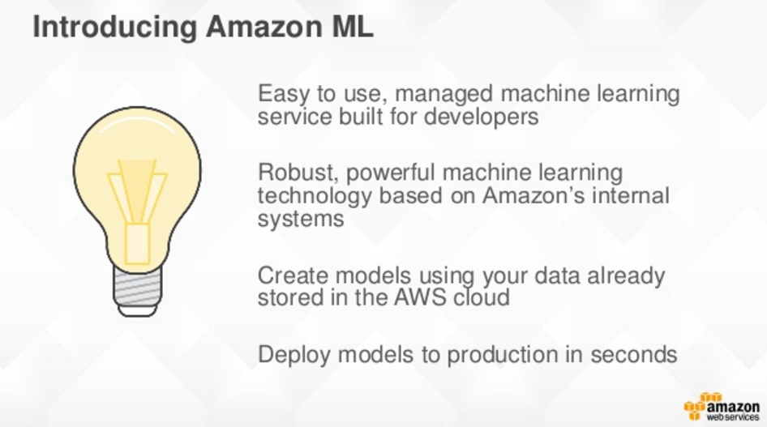

More information

Understanding Machine Learning: From Theory to Algorithms

http://www.cs.huji.ac.il/~shais/UnderstandingMachineLearning/copy.html

